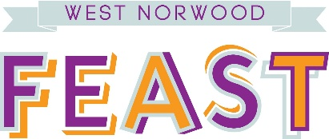

Volunteer Director – West Norwood Feast (WNF)
We are seeking a dynamic Director to join a small team which organises a much-loved community-powered market/Festival in West Norwood.
WNF is a well-established monthly community-focused market/Festival which features over 70 traders offering superb quality hot food, fresh produce, Arts and Crafts and Vintage products to the local community. Feast also features live music and children’s activities, and is a place where the whole community can gather for a great day out.
We are looking for someone with enthusiasm, who can help steer Feast through the next few years of development and growth and contribute fresh ideas for raising funds to make this possible.
If you have experience of fundraising/income generation at a strategic level in any field, we would like to hear from you. We would particularly welcome applications from people with a commitment to community projects and the ability to make connections in the local community and beyond.
Although knowledge of the local area would be desirable, we are interested in considering anyone who can demonstrate the following attributes:
- Ability to contribute new ideas for raising funds
- Enthusiasm for West Norwood Feast
- Energy and drive to get things done
- Ability to work collaboratively with others

Time Commitment: 5-6hrs per month, plus bimonthly Directors’ meetings

To Apply: Please complete the application form attached and send to hello@westnorwoodfeast.com

