Project Update

Norwood Road Trunk main replacement

Open cutting 840m to install a 600mm Ductile Iron trunk main.

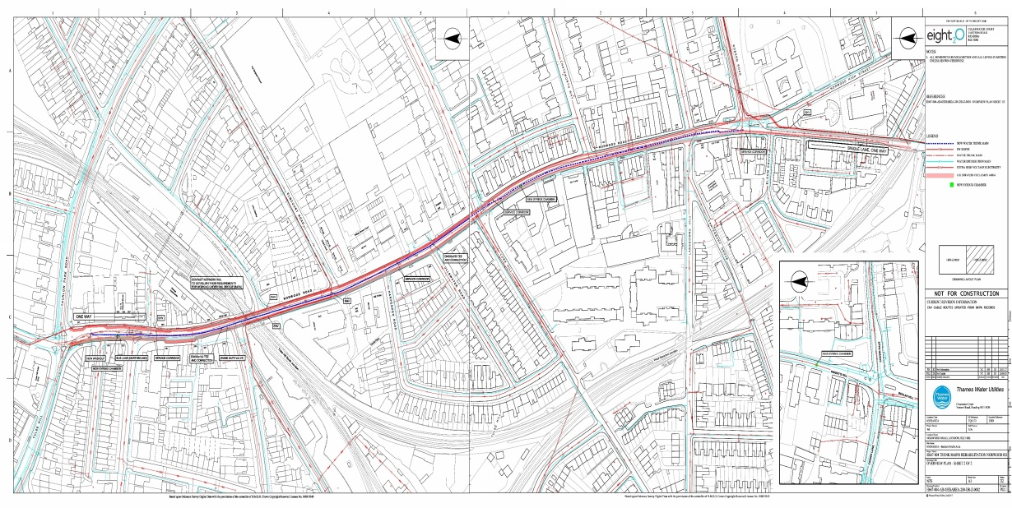

Started on site may 2019

- The summary scope of all works is as follows:
- New 600mm Ductile iron main from Thurlow park road along the busy A215 road to the junction of robson road
- A complex traffic management schemes
- Anchor joints
- Cross connection to the existing network
- Installation of Trunk Main Monitors & Chambers
- Installation of Various Thrust blocks
- Install x4 21” line stops with bypass to connect old to new.

Construction Work to Date
Phase 1
Installation of 22m of 600mm DI on the 300mm a pipe minder & pillar on Norwood road junction of Thurlow park road A205.
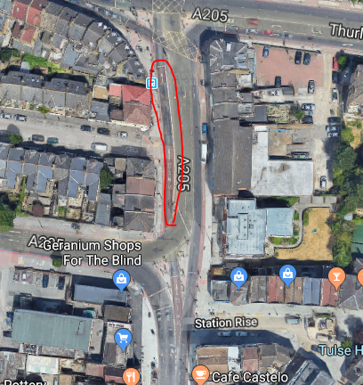

Phase 2/1
Installation 166m of 600mm ductile iron including 32m of wrapped pipe from Thurlow park road to the junction on Avenue park road. A205. The bridge section is was completed 28th August 2019.This section was minimalised to because to traffic management could proceed any further along Norwood road without 2 way traffic lights ,

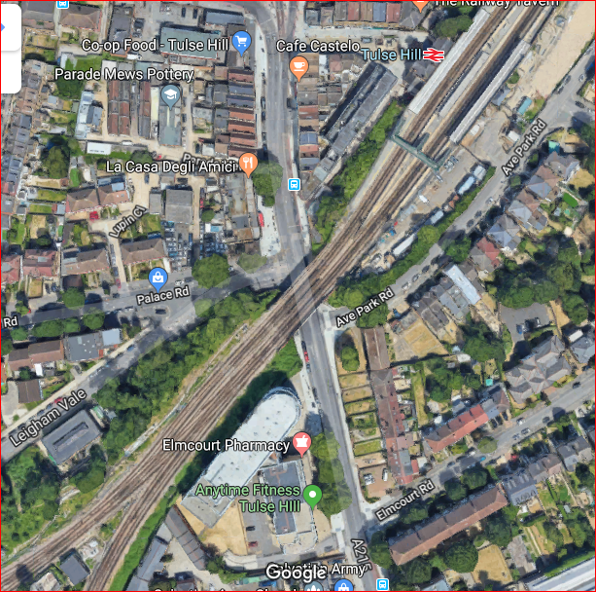
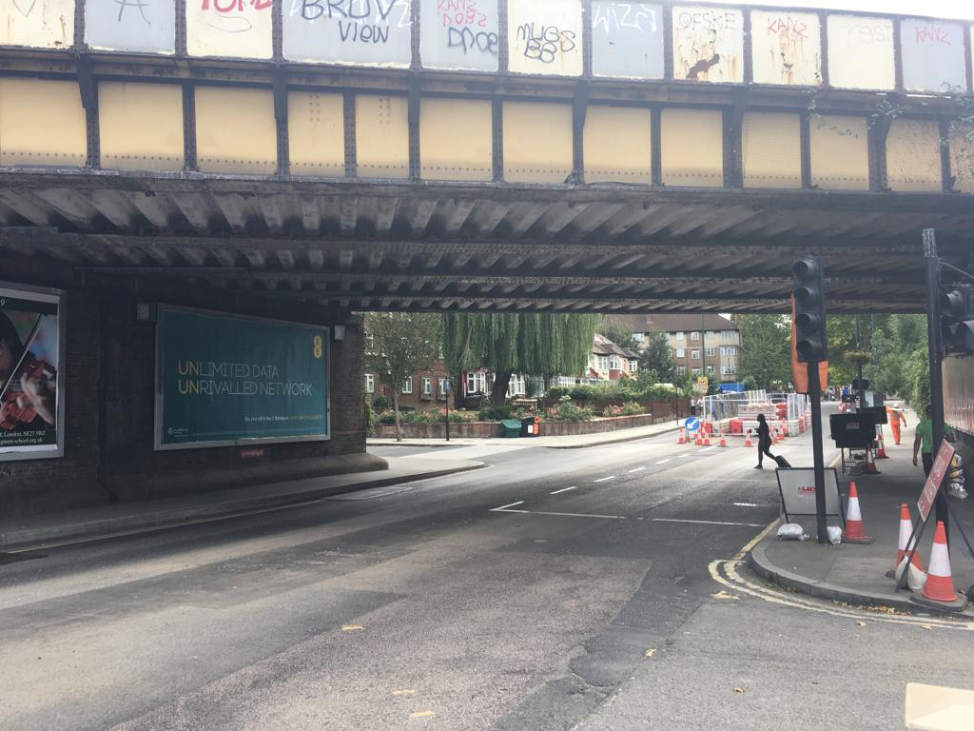
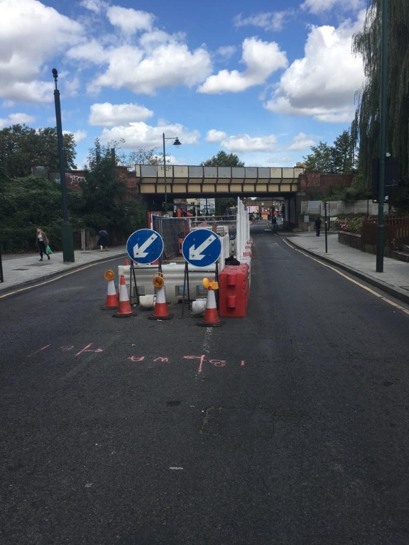
Phase 3
The Section(orange). 2 way traffic lights from Avenue park road to Elmcourt road is being installed from today 05th September 19 to start excavating trial holes for route proving once the TM set up is completed. 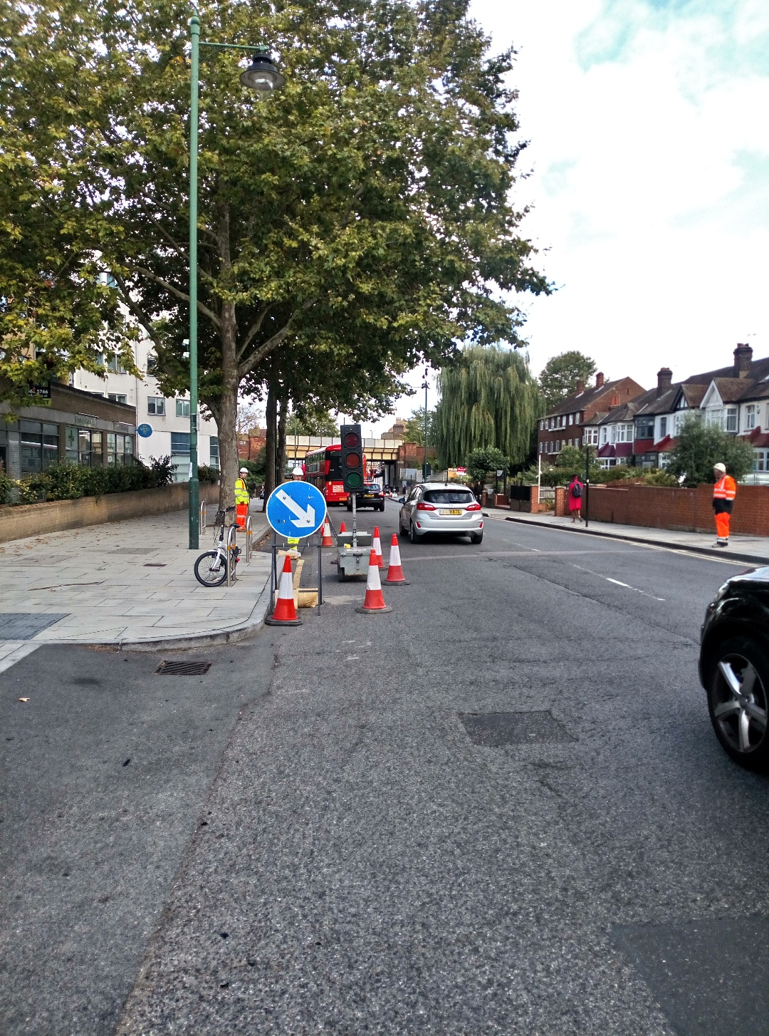
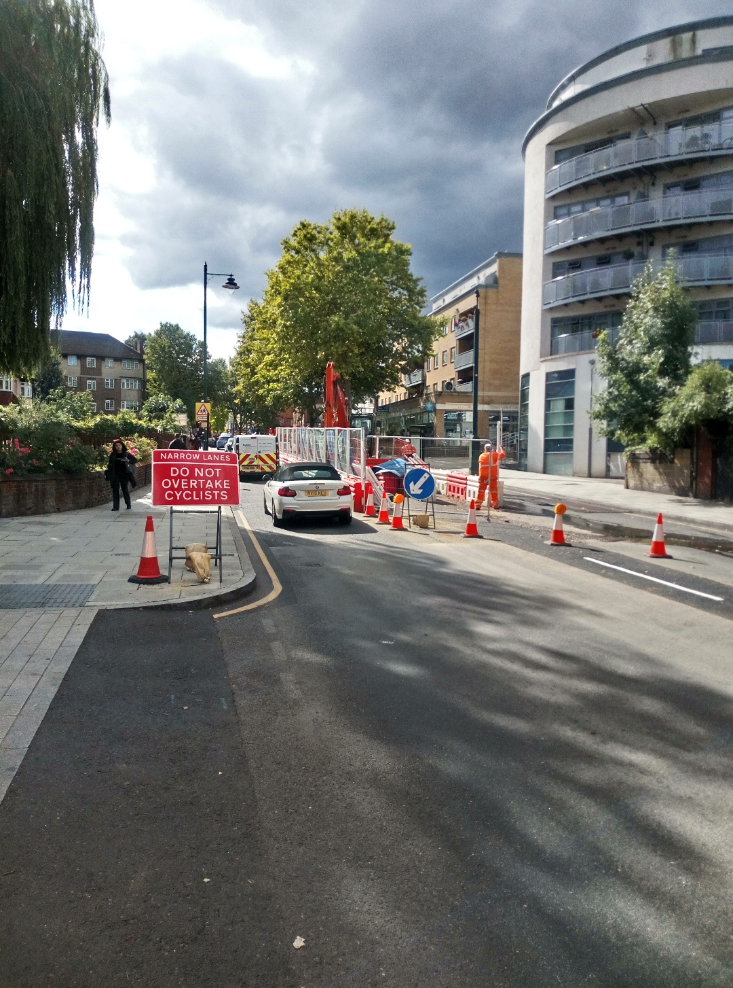

Phase 1A
Installation of 150m of 600mm ductile pipe x3 11.25 bends & x1 22 bend to navigate over a 42” cast iron trunk main & under an 18” gas main & 8” water main
X2 under pressure tees for a pipe minder & Sahara survey point & chamber in the footway.

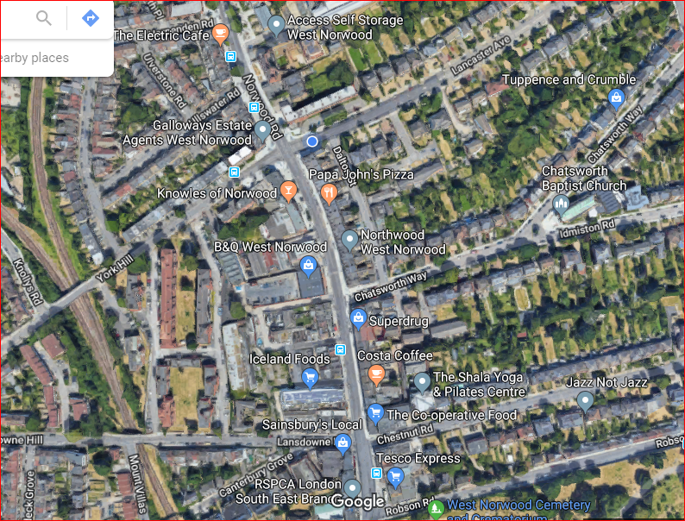
Phase 2A
When excavating trial holes next to the junction of Norwood road & Chatsworth way the team have come across a 900mm brick combined sewer at 1.3m deep. Instalcom are carrying out a survey on the line & level to send on to the design team, also carrying out trial holes opposite the junction of Wylett place to look for an alternative route.

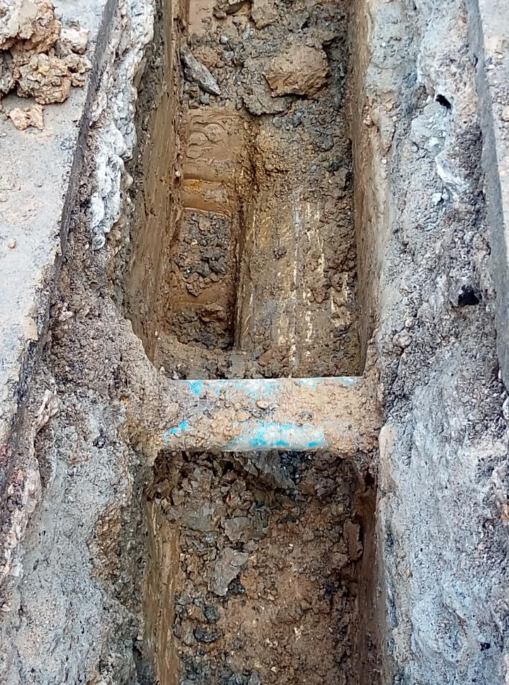
.

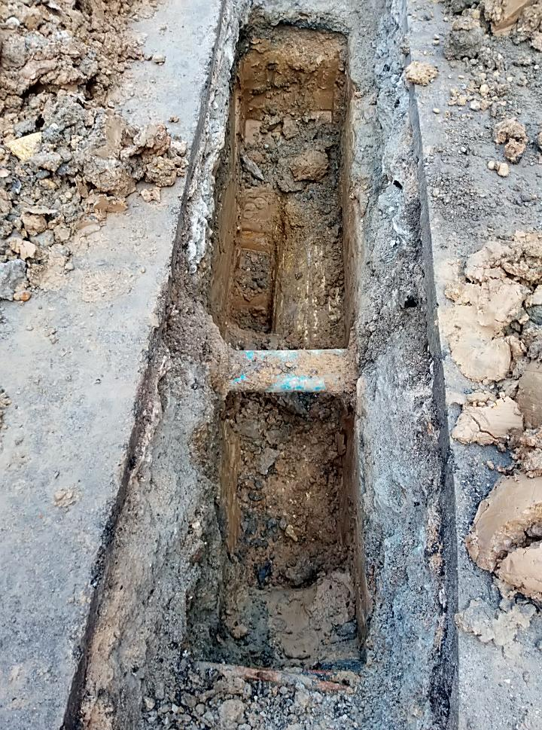

Phase 2a

This section of Traffic management has been removed temporarily to allow the 2 way lights to be set up at Phase 3
On Monday 9th September 19 there will a trial of 2 way light to see whether the traffic will still be able to move through 2 set of temporary lights without any interruptions
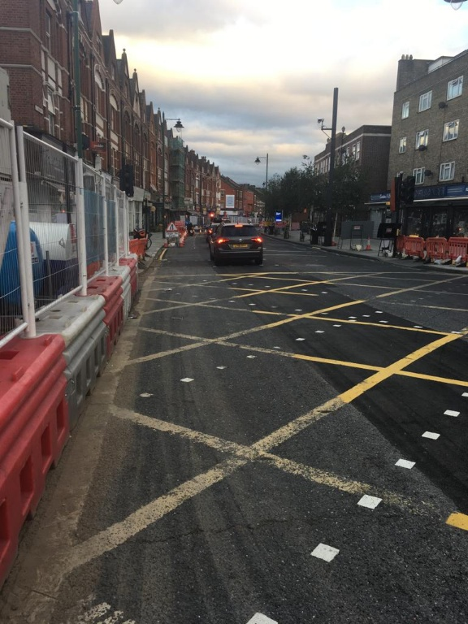

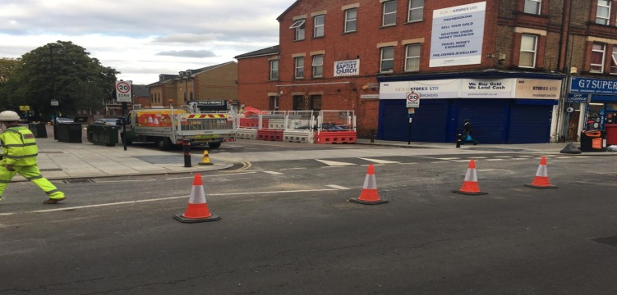

Description |  | Total to date (m)
New Mains Laid
Phase 1 |  | 22m
Phase 1A |  | 166m
Phase 2/1 |  | 150m
Total |  | 338m

