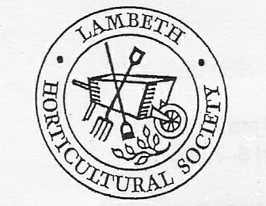

SPRING SHOW

Saturday 4 April

In the hope of spreading a little cheer, we are holding our spring show online and inviting entries in six classes:
- Floral: 3 Daffodils, 1 variety (without foliage)
- Floral: 3 Tulips, any variety (shown with foliage)
- Floral: A spring flower display in a vase
- Domestic: 3 Hot cross buns
- Children’s: An animal made from any recyclable material
- Children’s: A collage on the theme of “rainbows”
Rules for this show are
- No entrant may make more than one entry per class
- One photo only per class, multiple photos not permitted
- Entries to be received by 3 April
- Photos will be exhibited on Lambeth Horticultural Society’s Facebook page, with competitors’ names
- The judging will be by public votes (“likes”)
- The show is free to enter
- There will be a small prize for the winner in each class
- This is a new venture for us so please be patient!
To enter: Please email a photo of your entry/entries to publicity@lambethhorticulturalsociety.org.uk with your name, address and email address.

