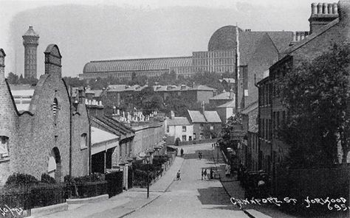

Would you like to discover who lived in your house and your street?
Then come to our meeting on
Thursday 19th September 7.30 pm
at Upper Norwood Library
Westow Hill SE19 1TJ
Norwood Society members will present their findings about Woodland Road, Woodland Hill, George Street (Cawnpore Street), and Chestnut Road. Discover where the hero of the Yangtze Incident, founder of the Free Evangelical Church in West Norwood, and the first international player for Crystal Palace FC lived.
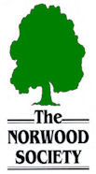
Entrance free and refreshments provided
Donations to help cover costs greatly appreciated.

