17 February 2023

Dear owner/occupier

Traffic signals modernisation work: Croxted Road/Thurlow Park Road junction

We will be shortly undertaking some work to modernise the traffic signals at the junction of Croxted Road and Thurlow Park Road. These signals are old and now need to be replaced. The new signals will include countdown facilities and utilise the latest extra low voltage and low carbon technologies.
The work will take place between 20 February and 9 June 2023.

How the work will affect you

The work will take place during the day between 08:00 – 17:00 Monday to Friday and between 09:00 – 13:00 on Saturdays. Whilst work is underway, we will need to temporarily close one lane at a time at the junction and temporary signals will be in place. We will also need to temporarily ban turns into Croxted Road from Thurlow Park Road for the duration of the work. This includes the Thurlow Park Road eastbound right-turn and Thurlow Park Road westbound right-turn into Croxted Road.
Our site office and staff welfare facilities will be located in some parking bays on Croxted Road adjacent to Lings Coppice.

Bus routes affected

We will be required to temporarily suspend bus stops at the Croxted Road/Thurlow Park Road junction which will impact routes P13, 3/N3 and 201. Please visit tfl.gov.uk/bus/status or follow @TfLBusAlerts on Twitter for live updates.

Pedestrians
We will provide alternative crossing points for pedestrians using the temporary traffic signals provided and where necessary, pedestrian walkways around working zones will be provided.

Contact us
If you have any concerns or comments, please call our Contact Centre on 0343 222 1234. Alternatively, you can write to:

TfL Customer Service
4th Floor
14 Pier Walk
London SE10 0ES

Yours faithfully
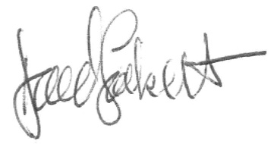

David Sockett
Head of Project & Programme Delivery (Assets),
Capital, Transport for London

