Key Messages for London’s Faith and CVS groups
(Updated 01/03/2022)

Current epidemiological context
London has seen a fall in cases in recent weeks. For the most recent week of complete data (12 February 2022 - 18 February 2022) 35,206 new cases were identified in London (391 cases per 100,000 population) compared to 49,881 cases (554 cases per 100,00) for the previous week. London has also seen a fall in the number of patients in hospital with COVID-19.

Staying Safe and reducing transmission
COVID has not gone away and it’s important that we continue to be cautious. We can all help prevent or reduce the spread of COVID-19 by:

- Getting vaccinated and having a booster
- Meeting people outside if possible
- Opening doors and windows to let in fresh air if meeting people inside
- Limiting the number of people you meet and avoiding crowded places
- Wearing a face covering on public transport and when it's hard to stay away from other people (particularly indoors or in crowded places)
- Washing your hands for at least 20 seconds with soap and water or using hand sanitiser regularly throughout the day
- Taking a rapid lateral flow test if you plan on spending time in crowded and enclosed spaces, or before visiting people who are at higher risk of severe illness if they get COVID-19.
- Isolating at home if you experience symptoms of COVID-19 and getting a PCR test.

COVID-19 will be a feature of our lives for the foreseeable future, so we need to learn to live with it and manage the risk to ourselves and others.

Vaccines continue to be our best line of defence. Those who are eligible but have not yet received their first, second or booster dose, are encouraged to take up the offer to help protect themselves and others. Evidence shows that the COVID-19 vaccination programme has already saved thousands of lives.

It is still possible to catch and spread COVID-19, even if you are fully vaccinated.
Although the legal requirement to self-isolate following a positive test result has been removed, anyone with symptoms or a positive test result should still stay at home and self-isolate. If you have symptoms of COVID-19, you should arrange to take a PCR test as soon as possible, even if you’ve been vaccinated. PCR testing will remain free of charge for anyone with symptoms until April 1st, 2022.

Staying safe and helping to prevent the spread of COVID-19

COVID-19 will be a feature of our lives for the foreseeable future, so we need to learn to live with it and manage the risk to ourselves and others. It is still possible to catch and spread COVID-19 even if you are fully vaccinated.

- The government is no longer asking people to work from home if they can. People should now talk to their employers to agree arrangements to return to the office.
- There is no longer a legal requirement to wear a face covering, the Government suggests that you continue to wear one in crowded and enclosed spaces, especially where you come into contact with people you do not usually meet. TFL strongly recommends you continue to wear face coverings when using its services,
- Venues and events are no longer required by law to check visitors’ NHS COVID Pass. However, some venues where large crowds gather or are in close contact may choose to continue to check the COVID-19 status of attendees and the workforce to keep everyone safer. More information can be found here.
- You are at higher risk of catching or passing on COVID-19 in crowded and enclosed spaces, where there are more people who might be infectious and where there is limited fresh air. Opening windows for just 10 minutes, or a small amount of time continuously where you can, makes a significant difference.
- Until 1st April, Lateral flow testing will continue to be free of charge. You may wish to take a rapid test as a way of manging your personal risk and the risk to those around you. This may be particularly important before visiting people who are at higher risk of severe illness if they get COVID-19.

More information can be found here.

Latest Policy Changes
From 24th February:
- Remaining domestic restrictions in England have been removed, including the legal requirement to self-isolate following a positive test.
- The Test and Trace Support Payment Scheme has now ended. Those who were told to self-isolate before 24 February can still make a claim up to 6 April.
- Additional local authority powers to tackle Covid-19 have ended. Local Authorities will manage local outbreaks in high-risk settings as they do with other infectious diseases.

Planned changes
From 24 March:
- COVID-19 provisions within the Statutory Sick Pay and Employment and Support Allowance regulations will end.
From 1 April:
- The Government will no longer provide free universal symptomatic and asymptomatic testing for the general public in England.
- The health and safety requirement for every employer to explicitly consider COVID-19 in their risk assessments will be removed.

Vaccine roll out
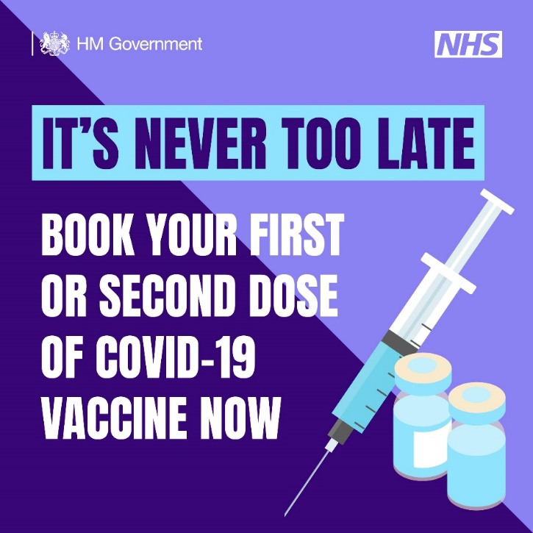
Vaccines are the most effective way to prevent many different infectious diseases. Most of us, including our children and wider families, have already had at least one, and they are responsible for stopping up to million deaths worldwide every year.

Over 6 million people in London, including the most vulnerable and those who care for them, have already received their first COVID-19 vaccine, just under 6 million have received their second dose and over 4 million people have now received their booster dose.

You can get a 1st and 2nd dose of the COVID-19 vaccine if you're aged 12 or over. You can book appointments at a larger vaccination centre or pharmacy, or find a walk in site here Find a walk-in coronavirus (COVID-19) vaccination site - NHS (www.nhs.uk).

Children Aged 12 - 15
Everyone aged 12 and over can now also get vaccinated with a 1st and 2nd dose. All children aged 12 to 15 can get a 1st dose from the day they turn 12. Most children can get a 2nd dose from 12 weeks after they had their 1st dose.

Most children will be offered a vaccination at school. They will be given the Pfizer/BioNTech vaccine for both doses. Children who do not attend school, for example if they are home schooled, will also be offered a vaccine. Parents and guardians will be contacted about when and where the vaccine will be offered.

Depending on your child's age, they may be offered another vaccine on the same day, including:

- flu vaccine
- HPV vaccine
- 3-in-1 teenage booster (Td/IPV vaccine)
- MenACWY vaccine

These are different vaccines and as a parent or guardian you will be asked to give consent for each vaccine.

If your child misses their COVID-19 vaccination, for any reason, or if you prefer to accompany your child to have their vaccination, you can also book an appointment here Book or manage a coronavirus (COVID-19) vaccination - NHS or find a walk in site here
Find a walk-in coronavirus (COVID-19) vaccination site - NHS

Booster vaccine
Everyone aged 16 or over who has had a second dose of a COVID-19 vaccine at least three months ago can get a booster dose. Children aged 12-15 can get a booster dose if they have a condition that puts them at high risk from COVID-19 or they live with someone who is immunosuppressed
You can:
- book a vaccination appointment online for a vaccination centre or pharmacy
- Find a walk-in coronavirus (COVID-19) vaccination site - NHS

When you have arranged your appointment, please make sure you attend.

For the vaccine to be effective, we need as many people to step forward as possible. Doing so means protecting ourselves, our parents, our grandparents, even our children from the impact of COVID-19. There is information available about the NHS COVID-19 vaccination programme including an easy-read guide to coronavirus and vaccinations.

Testing
People who have any of the following symptoms, even if they are mild, can still book or order a PCR test here. The main symptoms are:
- a high temperature – this means you feel hot to touch on your chest or back (you do not need to measure your temperature)
- a new, continuous cough – this means coughing a lot for more than an hour, or 3 or more coughing episodes in 24 hours (if you usually have a cough, it may be worse than usual)
- a loss or change to your sense of smell or taste – this means you've noticed you cannot smell or taste anything, or things smell or taste different to normal
From 1 April in England, the Government will no longer provide free universal symptomatic and asymptomatic testing for the general public. Limited symptomatic testing will be available for a small number of at-risk groups - the Government will set out further details on which groups will be eligible.
Until 1st April, you can still access free, rapid lateral flow tests (LFDs). You can either order testing kits online to be sent to your home or you can collect testing kits from a local pharmacy or testing site. If you cannot order online, then please call 119 (Lines are open 7am-11pm and calls are free).

You can still also be tested at a local testing site. Find a local testing site at:
Find where to get rapid lateral flow tests – NHS (test-and-trace.nhs.uk)

Self-Isolation
From 24 February, you are no longer legally required to self-isolate if you test positive for COVID-19..

You are also no longer legally required to self-isolate if you are an unvaccinated close contact and will no longer be advised to test for 7 days if you are a fully vaccinated close contact. New guidance will set out precautions for reducing risk to yourself and other From April, the Government will update guidance setting out the ongoing steps that people with COVID-19 should take to be careful and considerate of others, similar to advice on other infectious diseases. This will align with testing changes.
Useful resources

Caution
- Short film featuring Dr Amir Khan highlights importance of remaining cautious as those vaccinated can still pass on the virus

Places for worship, religious services, and gatherings
- COVID-19: guidance for the safe use of places of worship
- Coronavirus (COVID-19): Wedding and civil partnership ceremonies, receptions and celebrations

Vaccines
- General information provided by the NHS on the safety and importance of vaccines
- Video message on vaccine safety for BAME communities

General COVID-19 resources
- COVID-19 resources in your language: guidance and advice in various languages on topics such as health and wellbeing, employment and welfare, domestic abuse, housing and homelessness
- Doctors of the World have provided translated resources into 60 languages aimed at migrants and asylum seekers which are informed by government and NHS advice.

People with no recourse to public funds (NRPF)
- This tool gives information about where migrant families can get help with housing and financial support when they have no recourse to public funds (NRPF).

Migrant Health
- This resource provides advice and guidance for healthcare practitioners on the health needs of migrant patients and has been updated to include a summary of changes after the Brexit transition period and information on COVID-19 vaccination.

Mental Health
- Every Mind Matters: Coronavirus (COVID-19) and mental wellbeing
- The NHS Volunteers Service provide a telephone 'check in and chat' if someone has mental health issues and are feeling isolated during the pandemic, have a long-term condition, are self- isolating or have caring responsibilities. Call 0808 196 3646 (8am to 8pm, 7 days a week) or visit the website.
- People who care for or work with children and young people aged up to 25 who have been affected by COVID-19 (or other emergencies or individual crises) will be able to access a new online Psychological First Aid (PFA) training course. The online course, developed by PHE, offers training on how to provide practical and emotional support to children and young people affected by emergencies or crisis situations.

COVID-19 posters and social media resources
- The PHE campaign resource centre contains a collection of useful public health messaging resources for coronavirus
- Promotional material on COVID-19 vaccination: a guide for adults

