Ref: LBL/2023.24HIP-CW0

Highways Improvement Programme
NORWOOD ROAD – ANTI-SKID MEASURE

Dear Resident,

Lambeth Council via our framework contractor Ringway, will be completing the anti-skid measures on Norwood Road at the junction with York Hill originally planned for 2 August 2023 that could not be completed due to wet weather conditions. See attached plan of the site extents and the road closure diversion plan for information.

Details of the works
Night works will be carried out from:
- From evening of Wednesday 20 September to morning of Thursday 21 September 2023
- Works will take place from 23:50hrs to 06:00hrs.

It is expected that all works will be completed during this period, provided there are no unforeseen circumstances or weather conditions that may delay or prevent works taking place.

Things to note
The road will be closed between Chestnut Road to Ullswater Road junction during the works in sections, this means there will be no vehicular access within or across the area closed while works are being carried out for all vehicle users.
Your co-operation is essential – please do not park in the areas affected by the proposed works. Warning signage, diversion signs and barriers will be installed in the areas affected. This will require no vehicles to be parked in the road within the working and safety zones, as indicated by cones and suspension signs. Any obstructing vehicles will be relocated to nearby spaces/roads.

If you have special requirements or need to arrange access for people with disabilities, please contact us on the email address provided overleaf.

Contact us
We are committed to delivering efficient, safe projects and to keep our customers informed throughout. Our teams are always happy to answer questions about our work.
If you have any queries relating to diversions or traffic management during construction, please contact Ringway on the number or email address overleaf.

If you have any concerns on the new proposals, scheme specific issues or exemptions please contact Lambeth on the number or email address below.

Sincerely,

Chris Chrysostomou
Carriageway Project Manager

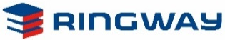

0845646 0059

Lambeth.schemes@ringway.co.uk

020 79269000

HIPresurfacing@lambeth.gov.uk

Bus Diversion Route
Route 2- will be diverted via Christchurch Road, Streatham Hill, Leigham Court Road, Crown Lane, Crown Dale, Elder Road to line of route.

Route N2- will be diverted via Christchurch Road, Streatham Hill, Leigham Court Road, Crown Lane, Crown Dale to line of route.

Bus Routes, 196, 432, 468 and N68- will be diverted via Christchurch Road, Streatham Hill, Leigham Court Road, Crown Lane, Beulah Hill before returning to line of route

Bus Routes 68 - will terminate on Christchurch Road.

Route 315 - will divert via Leigham Court Road, Crown Lane and Knights Hill in both directions.

Bus Route 322- will divert via Croxted Road, South Croxted Road and Gipsy Road in both directions.

Bus Route 415 - Not affected

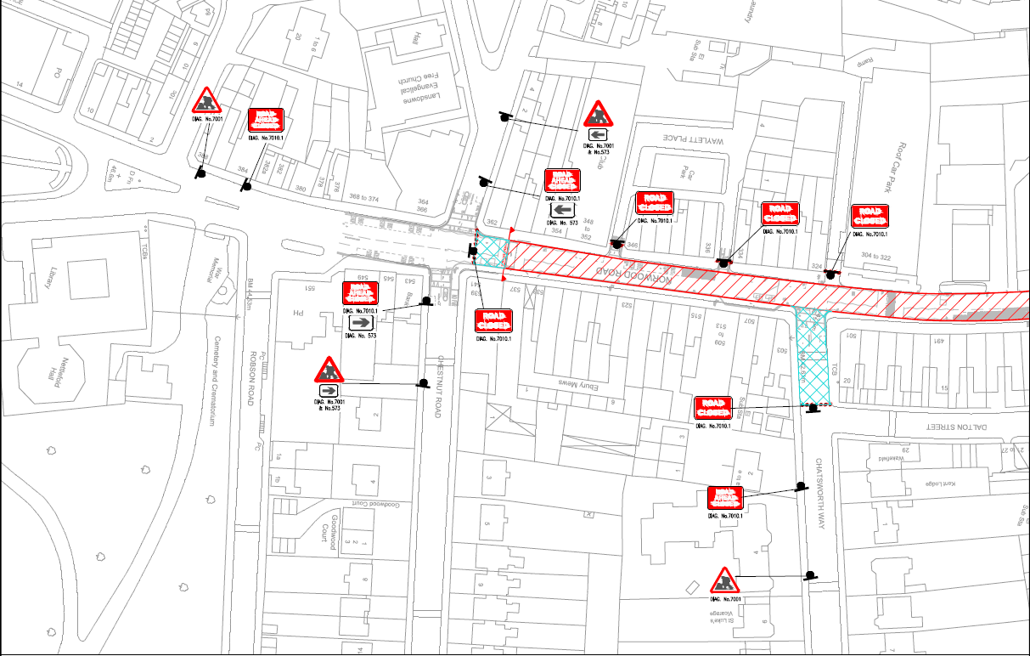

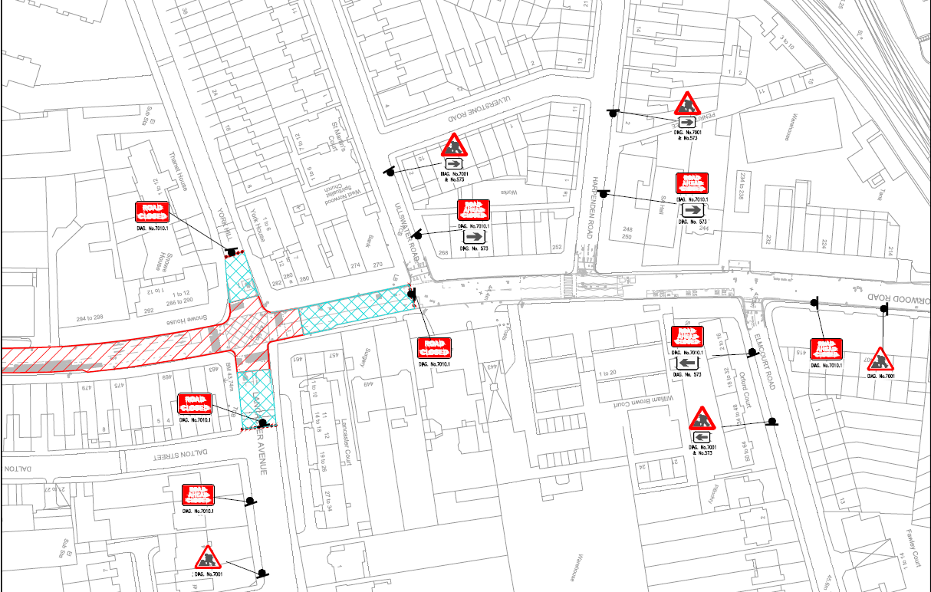

Diversion route
