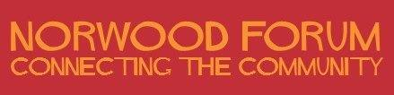

Annual General Meeting

Saturday 16 June 2018 (1:00pm – 3:00pm)

The Portico Gallery, 23a Knights Hill, SE27 0HS

AGENDA

- Welcome, Introductions and Apologies

- Minutes of the last AGM held on 1 July 2017 - and any matters arising

- Proposed changes to the Constitution (see report)

- Update on the new library:
- Head of Library Services: Susanna Barnes
- West Norwood Library Manager: Maria Kwofie

- Community groups: presentations

- Chair’s report 2017-18 (to be tabled)

- Treasurer’s report 2017-18 (to be tabled)

- Election of Norwood Forum officers and committee members (details of nominations received will be tabled):
- Chair
- Vice-Chair
- Secretary
- Treasurer
- Committee member (without portfolio) – up to 11 members

_______________________

Contact: info@norwoodforum.org
c/o The Old Library, 14-16 Knights Hill, West Norwood, London, SE27 0HY

