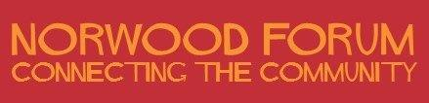

Annual General Meeting

Saturday 9 July 2022 (at approximately 2pm as part of a public meeting beginning at 1pm)

Venue: St. Luke's Church, Knights Hill, West Norwood, London, SE27 0HS

AGENDA

- Welcomes, Introductions and Apologies

- Minutes of the last AGM held on 3 July 2021 (here)

- Chair’s annual report 2021-22 (to follow)

- Treasurer’s report 2021-22 (to follow)

- Election of Norwood Forum officers and committee members

The 2021-22 Committee:
Chair: | Kim Hart
Vice-Chair: | Vacant
Treasurer: | Noshir Patel
Secretary: | Vacant
Ordinary Committee members | (up to 11):
 | Ibtisam Adem
 | Anne Crane
 | Jane East
 | Su McLaughlin
 | Gloria Orosungunleka
 | Philip Virgo

Details of nominations received for 2022-23 will be advised at the meeting.

Kim Hart, Chair
Norwood Forum
16 June 2022

Contact: info@norwoodforum.org
c/o The Old Library, 14-16 Knights Hill, West Norwood, London, SE27 0HY

